**MARSHFIELD R-I SCHOOLS**

**ATHLETICS/ACTIVITIES**

**HANDBOOK**



**2023-24**

***#bluejaypride***

***#MIM***

**WELCOME & INTRODUCTION**

**MSHSAA GUIDELINES FOR PARTICIPATION**

The Missouri State High School Activities Association and the Marshfield R-I School District set forth the following guidelines. Each athlete/activity participant must meet these requirements to be eligible to participate in MSHSAA sponsored interscholastic activities.

**Based on MSHSAA By-Law 2.1.1**

Eligibility to represent a school in interscholastic activities is a privilege to be attained by meeting the standards of eligibility cooperatively set by the member schools through this association and any additional standards set by a member school for its own students.

In order to represent the school the individual must be a bona fide student and meet all eligibility requirements. A bona fide student is one who is enrolled in and regularly attends classes at the member school, which meets the minimum academic requirements in MSHSAA By-Law 2.3.

**Based on MSHSAA By-Law 2.1.3**

An interscholastic activity shall be defined as any extra-class activity involving two or more schools in which two or more students participate who are identified with their schools.

**Based on MSHSAA By-Law 2.2.1**

Students who represent a school in interscholastic activities must be credible citizens and judged so by the proper school authority certifying a list of students for competition. Those students whose character or conduct is such as to reflect discredit upon themselves or their schools are not considered “creditable citizens.” Conduct shall be satisfactory in accord with the standards of good discipline set forth by the Marshfield R-I School District.

**Based on MSHSAA By-Law 2.2.2**

This includes conduct outside of school; students found guilty of a law violation shall not be eligible until they have satisfied the fine and or penalty. Students who have been charged with a crime must immediately communicate their status to the principal or athletic director so their eligibility status can be determined. (This would include D.W.I., minor in possession, or any other law violation). Failure to report law violations to the school administration could result in lost eligibility in all activities for 365 days.

A student shall not be considered eligible while under suspension. The student who is expelled or who withdraws from school because of disciplinary measures shall not be considered eligible for 365 days from the date of expulsion or withdrawal. *If a student misses class on the day of a contest, he/she shall not be considered eligible on that date and could not be certified eligible again until the student has attended a full day of classes without an unexcused absence.* Marshfield R-I Schools has an additional policy, which states that for Saturday participation a student must be in attendance the entire day on Friday unless the absence is excused. See Marshfield R-I Participation guidelines included in this booklet for further explanation.

**ACADEMIC REQUIREMENTS HIGH SCHOOL**

**Based on MSHSAA By-Law 2.3.2**

A student in grades 9-12 must have earned, the preceding semester of attendance, a minimum of 3 units of credit and shall currently be enrolled in and regularly attending courses that offer 3 units of credit. A beginning 9th grade student shall have been promoted from the 8th grade to the 9th grade for first semester eligibility. *This would mean for a student to remain eligible he/she must pass six of seven credit classes each semester previous to participation.* A student must be making satisfactory progress toward graduation as determined by local school policies.

**Based on MSHSAA By-Law 2.3.4**

A student who is dually enrolled in college and high school classes but who does not receive high school credit on his/her high school transcript for the college work, may have college hours earned during a regular semester count up to a maximum of 1 unit of credit toward determining high school eligibility as follows: ½ unit of high school credit for a 2 or 3 credit hour class; 1 unit of high school credit for a 4 or 5 hour college class.

**Based on MSHSAA By-Law 2.3.6**

Grades 9 – 12 Summer School: Secondary school-sponsored summer courses may count toward maintaining senior high academic eligibility for the FALL semester provided the following requirements are met:

* The counting of summer school classes must be first approved by the local school administration.
* The grade earned for the summer school course is placed on the student’s school transcript and counts toward graduation.
* Electives taken in any of the four core content areas (science, math, social studies and communication arts) may be counted toward this requirement of academic eligibility.
* No more than one credit earned in summer school shall count toward maintaining academic eligibility.

**Based on MSHSAA By-Law 2.3.10**

A student who was academically ineligible the preceding semester but meets the academic standard at the close of the semester becomes eligible the fifth day classes are attended in the succeeding semester.

**ACADEMIC REQUIREMENTS JR. HIGH**

**Based on MSHSAA By-Law 2.3.7**

A 7th or 8th grade student must meet the following requirements in order to participate in interscholastic activities:

A student must have been promoted to a higher grade or a higher level in special education at the close of the previous year. However, any incoming eighth grade student who failed more than one scheduled subject, or failed to make standard progress in special education, shall be ineligible the following grading period (grading period equals a quarter) regardless of promotion to the higher grade. Students promoted from the sixth to seventh grade are automatically eligible for the first quarter of their seventh grade year.

**Based on MSHSAA By-Law 2.3.9**

Summer School Grades 7 and 8: A student may regain eligibility for the first grading period of 8th grade who has failed more than one classes but no more than three the previous semester by passing the appropriate number of core classes through secondary-school sponsored summer school providing the following requirements are met:

* The counting of summer school classes must be first approved by the local school administration.
* The grade earned for the summer school course is placed on the student’s school transcript.
* Only core classes (science, math, social studies and communication arts) may count toward reinstatement of first grading period eligibility.

**ADDITIONAL ELIGIBILITY REQUIREMENTS**

While no one standard is more important than others, the MSHSAA suggests before the student drops any classes, for whatever reasons, or enrolls for classes in the upcoming semester, his/her coach, athletic administrator or principal should be consulted to verify that the student will meet the eligibility standards and to determine transfer standards, awards standards, and non-school standards.

The student must be a creditable high school citizen.

The student cannot be 19 years old prior to July 1 preceding the opening of school.

The student cannot have graduated from a four-year high school.

The student cannot have attended eight semesters of high school.

The student cannot have competed in four seasons of a particular sport.

The student must have entered school within the first eleven days of the semester.

The student must be enrolled in courses offering 3 units of credits (this is normally 6 courses)

The student must have earned 3 units of credit the preceding semester.

The student cannot have played sports under a false name.

The student cannot commit an unsportsmanlike act while attending or participating in a high school activity.

**STUDENTS ENROLLED IN SPECIAL EDUCATION PROGRAMS**

A student may be eligible to participate in MSHSAA regulated activities if he or she is enrolled in a full course at his or her level in special education program for the handicapped which is approved by the Missouri Department of Elementary and Secondary Education which though un-graded, enrolls pupils of equivalent age, and the student made standard progress for his or her level the preceding semester.

**HIGH SCHOOL SEASONS OF PARTICIPATION**

**Based on MSHSAA By-Law 2.4.1**

A student shall not participate in more than four seasons in grades 9-12 in any interscholastic activity. A student shall have only eight consecutive semesters (four consecutive years) of eligibility in high school, in which he/she may participate in one season per year in an activity.

**JR. HIGH SCHOOL SEASONS OF PARTICIPATION**

**Based on MSHSAA By-Law 2.4.2**

A student is eligible for only TWO SEMESTERS in each the seventh and eighth grade beginning with the first semester of entrance in each grade. A student repeating a grade is not eligible.

**AMATEUR AND AWARDS STANDARDS**

**Based on MSHSAA By-Law 3.6.2**

Students may not receive cash or merchandise for participating in an athletic or activity contest. Any awards presented must be symbolic in nature such as medals or ribbons and the retail value cannot exceed $100.00.

**HIGH SCHOOL AGE REQUIREMENTS**

**Based on MSHSAA By-Law 3.5.1**

A high school student shall not have reached the age of 19 prior to July 1 preceding the opening of school. If a student reaches the age of 19 on or following July 1, the student may be considered eligible for the upcoming school year.

**JR HIGH AGE REQUIREMENTS**

**Based on MSHSAA By-Law 2.4.1**

To be eligible for junior high school competition against teams all in a particular grade classification, the student shall not have reached the following ages prior to July 1 preceding the opening of school: Grade Seven— 14; Grade Eight—15.

**NON-SCHOOL COMPETITION**

**Based on MSHSAA By-Law 3.1.3**

Students may not practice for or participate with a non-school team or in any organized non-school athletic competition in the *same sport* during the *same season*. Students may participate on a school team and a non-school team in different sports during the same season. Students may not practice with or participate for a non-school team or organized non-school athletic competition on the same day that they practice or participate for the school team without the approval of their school administration.

A student participating in non-school competition during the school year but outside the school-sponsored sports season may not receive coaching from any member of the school’s coaching staff from the school that student attends or any member of the school’s staff of the school he/she will attend the following year.

Any questions regarding participation in non-school competition should be directed to the athletic director prior to participation. Failure to check on the legality of an activity could cost the student eligibility in the activity.

**PHYSICAL EXAMINATIONS AND PROOF OF INSURANCE**

**Based on MSHSAA By-Law 3.8.1 and 3.8.2**

A student in athletics and cheerleading must have a physical examination by a qualified physician. This form is ***valid for 2 years*** and is to be kept on file in the office of the athletic director. In order for this physical exam to be valid, the parent or guardian giving the student permission to participate ***must have signed it.*** Any preexisting condition that has prohibited the student from participating must have a Doctor’s note with the physical examination.

Each student who participates in athletics is covered with a minimum insurance policy; a letter explaining its coverage is given to athletes at the beginning of the sports season. All parents are encouraged to have some kind of additional coverage on their student who participates in athletics. A student must have a current completed physical form on file before he/she can participate in practice.

Each student who participates in athletics and cheerleading will receive the ABC’s of Concussions form. Parents and students must sign the concussion statement located on the physical form.

**TRANSFER STUDENTS**

**Based on MSHSAA By-Law 3.10.4**

The student’s parents must have moved with him/her to the Marshfield R-I School district. The student’s enrollment must have been continuous for at least 365 days at his/her school if his/her parents have moved out of that school district.

The student cannot have been influenced by any person to transfer schools.

If a student enters a school other than the public school in his/her home district in which the parents reside and then transfers to his/her home school, the student must attend one 365-day period to become eligible.

Each new student wishing to participate in activities must have a transfer of eligibility form on file before he/she is allowed to participate.

**NCAA ACADEMIC ELIGIBILITY**

The provisions of NCAA Bylaw 14.3 stipulate that a student-athlete entering an NCAA Division I or II member institution must meet certain requirements to be eligible for financial aid awarded by the institution or to practice and compete on an intercollegiate team during the first year of attendance**.** This information can be obtained through the counselors. Prospective college athletes must be registered with the NCAA Clearinghouse. A copy of the NCAA guidelines can be found on pages 14-18.

**MARSHFIELD R-I PARTICIPATION GUIDELINES**

Students are free to make their own selections as to the activities in which they wish to participate. It is the R-I policy that students facing a scheduling conflict between R-I sponsored activities will be given a choice of which to attend. Certain school activities (to be determined by the administrators) will have priority. Students are not to be penalized by the activity not attended.

All students will be transported to and from respective activities via school transportation. The only exception to this is when a parent makes a request to personally transport the student home after the event and contacts the head coach personally to seek permission. Parents can only transport students home, and only in extenuating circumstances where the student is involved in two school activities can parents transport students to activities. The Activities Director or Principal must grant permission for parents to transport students to activities. The parent should personally sign the student out with the coach following the activity.

A student must be in attendance the entire school day in order to participate in practice or games unless the absence is excused in advance. Ms. Hubbard, Mr. Curley, Ms. Thompson or Mr. Hurley must clear unavoidable absences for High School students ***in advance***. Junior High students must have their unavoidable absences cleared by Ms. Grandel or Mr. Hyde. Unavoidable absences might include: *funerals, doctors & dentist* *appointments, etc*. If a student misses school on the day of a contest because of illness, he/she will be ineligible to participate on that day. For Saturday participation, the student must be in attendance the entire day Friday. The exception to this rule would be a student missing class on Friday with an excused absence. In this case the parent should make contact with the school administration so the student’s eligibility status can be communicated to the coach. If it is necessary to be absent from practice, the student is expected to obtain permission from the head coach *prior* to the scheduled practice.

In the event a truancy or suspension takes place, the student will *not* be eligible for participation until he/she has fulfilled the disciplinary requirements established by the administration.

**Activity Fees**

All students who choose to participate in a MSHSAA sponsored athletic event must pay an activity fee of **$50.00** per student per year at the high school and $30.00 per student per year at the junior high. Families with multiple student athletes will have a $100.00 cap per year per family at the high school and $60.00 per year per family at the junior high. If a family has a high school student and a junior high student a cap of $100.00 per family per year will be in place. Families who qualify for free or reduced lunches may qualify for a reduced rate. Please see Ms. Hubbard (High School) or Mrs. Grandel (Junior High) for more information.

**HIGH SCHOOL DANCE INFORMATION**

Football Homecoming Sponsored by Student Government Association/

Chaperoned by the Sophomore Class Sponsors and Winter Coaches.

Rally Day Sponsored by Student Government Association/

Chaperoned by the Fall coaches.

Junior and Senior Prom Sponsored by Junior Class Prom Committee/

Prom Sponsor

Chaperoned by the Junior Class Sponsors

**Dance Regulations (all school rules/consequences apply)**

1. Possession or use of any unauthorized chemicals is forbidden. Violators will be turned over to the proper legal authorities and the privilege to attend all school activities will be removed.
2. Possession or use of tobacco is forbidden. Students in violation will have to leave the party and will not be permitted to attend any other parties. Other actions may be taken.
3. All other violations of rules will be handled in accordance with the regular school discipline code.
4. Students who leave the party will not be permitted to return.

**Guidelines for Guests Attending Dances**

A Marshfield High School student may bring one date who is a high school student or a high school graduate, to any All-School Dance other than Prom. *Dates must be at least 14 and no older than 20 years of age. No jr. high students will be allowed.* A guest application for a non-MHS student must be filled out by the MHS student, signed by his/her parents and on file in the office for each dance. The application is available in the high school office.

The MHS administration must approve all guest applications. Each student and his/her date **must have purchased a ticket** for the event prior to the event. Tickets will not be sold at the door for any dance unless approved by the administration. A student must be in attendance all day the day of the dance. A Friday absence must be excused for the student to attend a Saturday dance.

**Prom**

Prom is a formal dance given by the junior class to honor the senior class. It is an event that should be the highlight of a student’s high school career. Prom is not an “all-school” dance and is restricted to juniors and seniors and their dates. A MHS junior or senior bringing an out-of-school date or MHS underclassman as a date must follow the guidelines for attendance mentioned above. A student is encouraged to bring a date but should feel free to come to prom without a date if he/she so chooses.

**ALCOHOL AND DRUG USE**

The possession or use of alcohol, tobacco, or nonprescription drugs is known to be detrimental to the individual as well as the team he/she represents. Therefore, disciplinary action will be taken.

A student charged with crimes involving drugs and alcohol will lose eligibility in accordance with MSHSAA By-Law 2.2.1 until all charges have been dropped or the student has satisfied all requirements of the court with exception of probation.

**Discipline Concerning Drugs and Alcohol**

A minimum ***twenty-eight (28) calendar day suspension*** from participation or attendance in all extracurricular and/or co-curricular activities shall be assessed for use, possession or distribution of alcohol and/or illegal drugs including all controlled substances, counterfeit drugs, and other substances purported to be drugs. Drug violations also include possession of drug paraphernalia. *If the violation occurs when a student is NOT involved in an activity/sport the suspension would begin with the next activity/sport the student participates in, unless they do not participate in any activities/sports for 2 consecutive semesters. During the twenty-eight (28) day suspension the student will be permitted to participate in practice, but will not be allowed to compete in games or travel with teams.*  A suspension can overlap from one sport to another. A second drug and/or alcohol violation would mean the student would be suspended *for three hundred and sixty-five (365) calendar days*. A third drug and/or alcohol violation would mean suspension for the length of the student’s enrollment in the Marshfield R-I Schools. Student athletes need to realize that the disciplinary action governs all years of participation. For example, a student receiving a violation during his/her freshman year, a second violation during his/her sophomore year, a third violation during his/her junior or senior year would constitute a suspension from activities the remainder of his/her years of enrollment.

A student who tests positive for an illegal substance will be provided with information concerning the availability of receiving a chemical dependency assessment by a Certified Substance Abuse Counselor.

**Discipline concerning Tobacco**

A minimum ***seven (7) calendar day suspension*** will be assessed from participation and or attendance in all extracurricular and/or co-curricular activities for use, possession or distribution of all forms of tobacco and other substances purported to be tobacco. Drug violations also include possession of drug paraphernalia. If the violation occurs when a student is NOT involved in an activity/sport the suspension would begin with the next activity/sport the student participates in, unless they do not participate in any activities/sports for 2 consecutive semesters. During the seven (7) day suspension *the student will be permitted to participate in practice, but will not be allowed to compete in games.* A second violation for use, possession or distribution of all forms of tobacco and other substances purported to be tobacco would constitute a twenty-eight (28) calendar day suspension. During the twenty-eight (28) day suspension the student will not be permitted to participate in any activity outside the regularly scheduled class time, i.e., practice, games, competitions. A third violation would mean the student would be suspended *for three hundred and sixty-five (365) calendar days*.

**HAZING**

**Anti-Hazing Policy**

Hazing is defined as, including, but not necessarily limited to, any action or situation created, whether on or off school premises, which might reasonably be expected to result in mental or physical discomfort, embarrassment, harassment, or ridicule. This definition includes the following activities:

Paddling

Creation of excessive fatigue

Physical and psychological shocks

Quests, treasure hunts, scavenger hunts, road trips, or related activities

Requiring or encouraging the wearing of apparel in public that is conspicuous and normally not considered in good taste

Public ridicule of students, including morally degrading or humiliating games and activities

Late work sessions, excessive time demands, or other requirements that interfere with academic performance

Demanding or encouraging any other activities that conflict with civil law and/or school policies

Disciplinary consequences will occur to anyone or any team found to be guilty of hazing.

According to Missouri state statutes, “consent” to hazing is not a defense.

**SPECIALIZATION**

Although some students may choose to specialize in a particular activity, the Marshfield R-I School staff strongly encourages students to participate in a variety of activities and athletics throughout the school year. We are committed to building multi-sport athletes for all of the positives it provides the student.

**SPORTSMANSHIP**

Through the activities program MHS students and fans come in contact with many students, fans, and athletic officials. The Marshfield school and community should always be represented by appropriate and respectful behavior at all times**.** Sportsmanship must always be at the highest level! Students and fans unable to maintain an appropriate level of respect for the opposing team, opposing fans, or athletic officials will be asked to leave the event.

**LEAGUE ACTIVITY**

Marshfield High School is a member of the ***BIG 8 CONFERENCE*** for sports and other activities. The conference at present has the following fourteen member schools: *Marshfield, Reeds Spring, Rogersville, Hollister, Springfield Catholic, Mt. Vernon, Monett, McDonald County, East Newton, Aurora, Cassville, Seneca, Nevada, Lamar.*

**ADMISSION TO EVENTS**

The admission charge to all school activities where a charge is made will be $4.00 for adults and $2.00 for students. Multiple game passes may be purchased. Senior citizen passes are available at the athletics office for patrons *60 years* of age and older.

Marshfield High and Jr. High School athletes are issued a pass to attend all home games once they have **paid their athletic fee**. These passes MUST be PRESENTED to enter the events for free.

**HIGH SCHOOL SPORTS LETTERING REQUIREMENTS**

**FOOTBALL**- Students must play in at least one-half of all quarters, be recommended by the coaching staff, show good sportsmanship and leadership at all times, or start on varsity at the end of the season. Injured starters receive a letter. The head coach is **Cody Bull.**

**BASKETBALL**- Students must play in at least one-fourth of all quarters, meet for practice sessions, complete the season as a member of the squad, show good sportsmanship and good citizenship at all times. The head coach for girls is **Katie Pritchard** and the head coach for boys is **John Cherne**.

**TRACK**- Students must place first in a dual or triangular meet, or place at least third in a league or district meet; must complete the season as a member of the squad; show good sportsmanship and good citizenship at all times; be recommended by coaching staff; and accumulate a total of twelve points. When a meet is canceled due to weather, the next equivalent meet will be double scored (for lettering requirements) for each individual’s accumulated points. The head coach is **Roy Kaderly.**

**CROSS COUNTRY**- Students must run in one-half of the Varsity meets, be recommended by the coaching staff, show good sportsmanship and leadership at all times, and complete the season as a member of the squad. The head coach is **Gage Miers.**

**BASEBALL**- Students must play in at least one-fourth of all varsity innings, meet for practice sessions, complete the season as a member of the squad; show good sportsmanship and good citizenship at all times. The head coach is **William Pate.**

**SOFTBALL**- Students must play in at least one-fourth of all varsity innings, meet for practice sessions, complete the season as a member of the squad; show good sportsmanship and citizenship at all times. The head coach is **James McAnarney.**

**GOLF**- Participants must compete in one-half of the scheduled meets as one of the five declared varsity players. This is subject to change according to the total number of meets. He/she must meet for practice sessions and complete the season as a member of the team and be recommended by the coach. The head coach for boys is **Reggie Smith** and the head coach for girls is **Cheratin Hunter.**

**VOLLEYBALL**- Students must compete in one-half of all varsity regulation games, must not have missed over three scheduled practices unless excused, must end the season as a team member and have demonstrated good sportsmanship and leadership. The head coach is **Jarod Olson**.

**WRESTLING**- Students must compete in one-half of the varsity wrestling meets, meet for practice sessions, complete the season as a member of the squad, show good sportsmanship and good citizenship at all times. The head coach for girls is **Adam Wright** and the head coach for boys is **Matt Holt.**

**SOCCER**- Students must compete in one-half of all varsity halves of games; complete the season as a member of the squad, show good sportsmanship and good citizenship at all times. The head coach for girls is **Paul Lewis** and the head coach for boys is **Tom Searson**.

**SWIMMING-** Lettering requirements to be announced. The head coach is **Bailee Nunn.**

Each head coach may award a letter in a situation where he/she and the athletic director feel it is justified.

**PROVISIONAL LETTER**- An athlete who has not met the varsity letter requirements but has made a significant contribution to the program and plays the sport the following year and meets all the varsity letter requirements will be given credit for the previous year and thus considered a varsity letter winner for two years.

**PARTICIPATION AWARD**- This includes a student who participated in a sport but did not earn a letter. (A certificate of award is presented.)

**BAND**-The “M” award in music can be earned in band. The student must meet the requirements as set up by the department. Attendance, attitude, dependability, as well as high caliber musicianship are some of the requirements for these awards. Band Director **Dan Wyman**.

**VOCAL MUSIC**- To letter in vocal music the student must attend all concerts, competitions, etc. Exceptions to this are sickness, death, etc. The student must maintain a “B” average in Honor/Mixed Chorus. Dependability, responsibility, citizenship, attendance, and cooperation will be a major consideration in determining who will letter. and the Chorus Council will approve letters. Vocal Music Director is **Juliana Beatie**

**MSHSAA EXCELLENCE AWARD, SPORTSMANSHIP AWARD & OUTSTANDING ATHLETE AWARD**- Chosen by a committee of varsity head coaches. Male and female senior athletes will be chosen for each award. A plaque shall have the recipient’s name and the year presented added each year that the presentation is made. The recipient of the award(s) shall also be presented with a small plaque. This award shall be presented during the Activities award ceremony.

**CO-CURRICULAR ACTIVITIES**

**CENTERSTAGE** - Sponsored by **Mrs. Valerie Stockton**, this club is open to any students showing special interest in speech and drama.  A student desiring membership should submit an application to the club president.

**FBLA** - Future Business Leaders of America promotes an interest in the field of business. Membership is open to any student enrolled in a business class. The teachers in the business department sponsor this organization. This group is sponsored by **Mrs. Harrison.**

**FCCLA** – Family, Career and Community Leaders of America, sponsored by **Mr. Bauer** and **Mrs. Replogle**, is a national organization that helps youth become strong leaders.

**FFA** - Marshfield's FFA chapter, sponsored by **Mr. Cron** and **Mr. Koenig**, is a leadership development organization for students enrolled in agriculture education.

**SCHOLAR TEAM**-Lettering requirements to be announced. The sponsor is **Angela Hoefer.** Each head coach may award a letter in a situation where he/she and the athletic director feel it is justified.

**HARRY POTTER CLUB** – The club is for students with an interest in Harry Potter. This group is sponsored by **Mrs. Otradovec.**

**MESA** – Marshfield Equestrian Student Association, sponsored by **Mrs. Fields**, is for students with an interest in horses and trail riding.

**NATIONAL ART HONOR SOCIETY** - The National Art Honor Society is designed specifically for high school student’s grades 10-12, for the purpose of inspiring and recognizing those students who have shown an outstanding ability in art. The sponsor is **Mrs Glenn.**

**NATIONAL HONOR SOCIETY:**

Membership in the Marshfield High School chapter of the National Honor Society is an honor bestowed upon selected students. Selection for membership is by a faculty council and is based upon outstanding scholarship, character, leadership, and service. Once selected, members have the responsibility to continue to demonstrate these qualities. The sponsor is **Austyn McAnarney**

 The selection procedure shall commence after grades have been posted for the 1st semester.

Step 1. Junior and senior students must meet the scholastic requirement of a 3.0 GPA.

Step 2.  A student who qualifies scholastically will be notified of his/her scholastic eligibility by letter, and invited to apply for membership by picking up the appropriate forms from the NHS sponsor, and returning the forms by the appropriate deadline, completed and signed.

Step 3.  A list of applicants shall be compiled and teachers will rate applicants in character, leadership, and service using a rating scale. Teachers will evaluate only those students they have in class or sponsor in an organization.

Step 4.  The faculty council shall meet to review the applications and ratings from the faculty, and select the NHS members.

Step 5.  All new NHS members will be notified by mail, and shall be invited to attend the formal induction ceremony.

**P.R.I.D.E.** - A club that supports the LGBTQ community sponsored by **Ms. Plemmons.**

**QUILL AND SCROLL** – This club is for students who are interested in creative writing, poetry, short stories, plays, and novels. **Mrs. Ragsdale** is the sponsor.

**STUDENT GOVERNMENT ASSOCIATION / CABINET**- Sponsored by **Mrs. Rost** and **Mrs. James**, this group is the school's leadership organization for student government.

**S.O.D.A. CLUB** – Students Opposing Destructive Actions.  This club is open to all students grades 9-12. Their goals are to work toward a drug-free society and community service. **Kim Plemmons and Aimee Quinlivan**

**TECHNOLOGY STUDENT ASSOCIATION** – Sponsored by **Mr. Pennington and Mr.** **Zweerink,** this club is for any student interested in advancing his/ her knowledge and leadership skills in the ever-changing field of technology.

**NON-CURRICULAR ACTIVITIES**

**FELLOWSHIP OF CHRISTIAN ATHLETES** - Custodians are **Mrs. Reed and Mrs. Pugh**. This group is nationally affiliated and is designed to offer students an opportunity to have Christian fellowship with their peers.

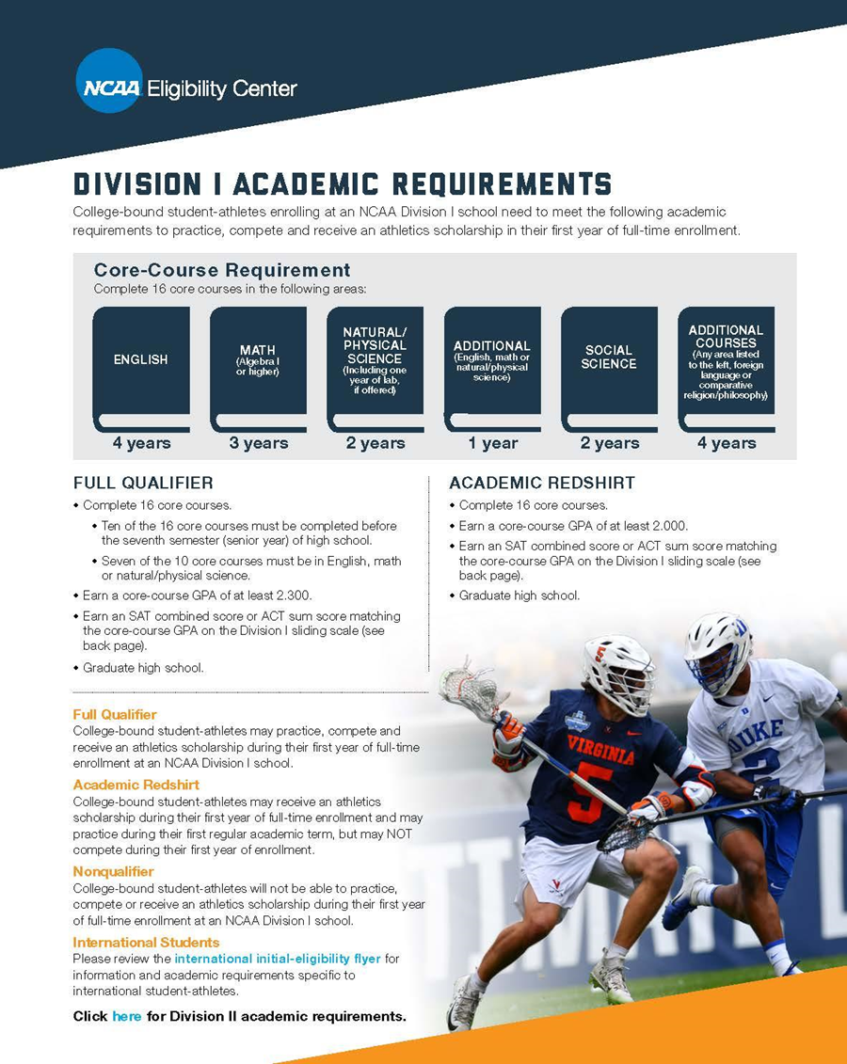

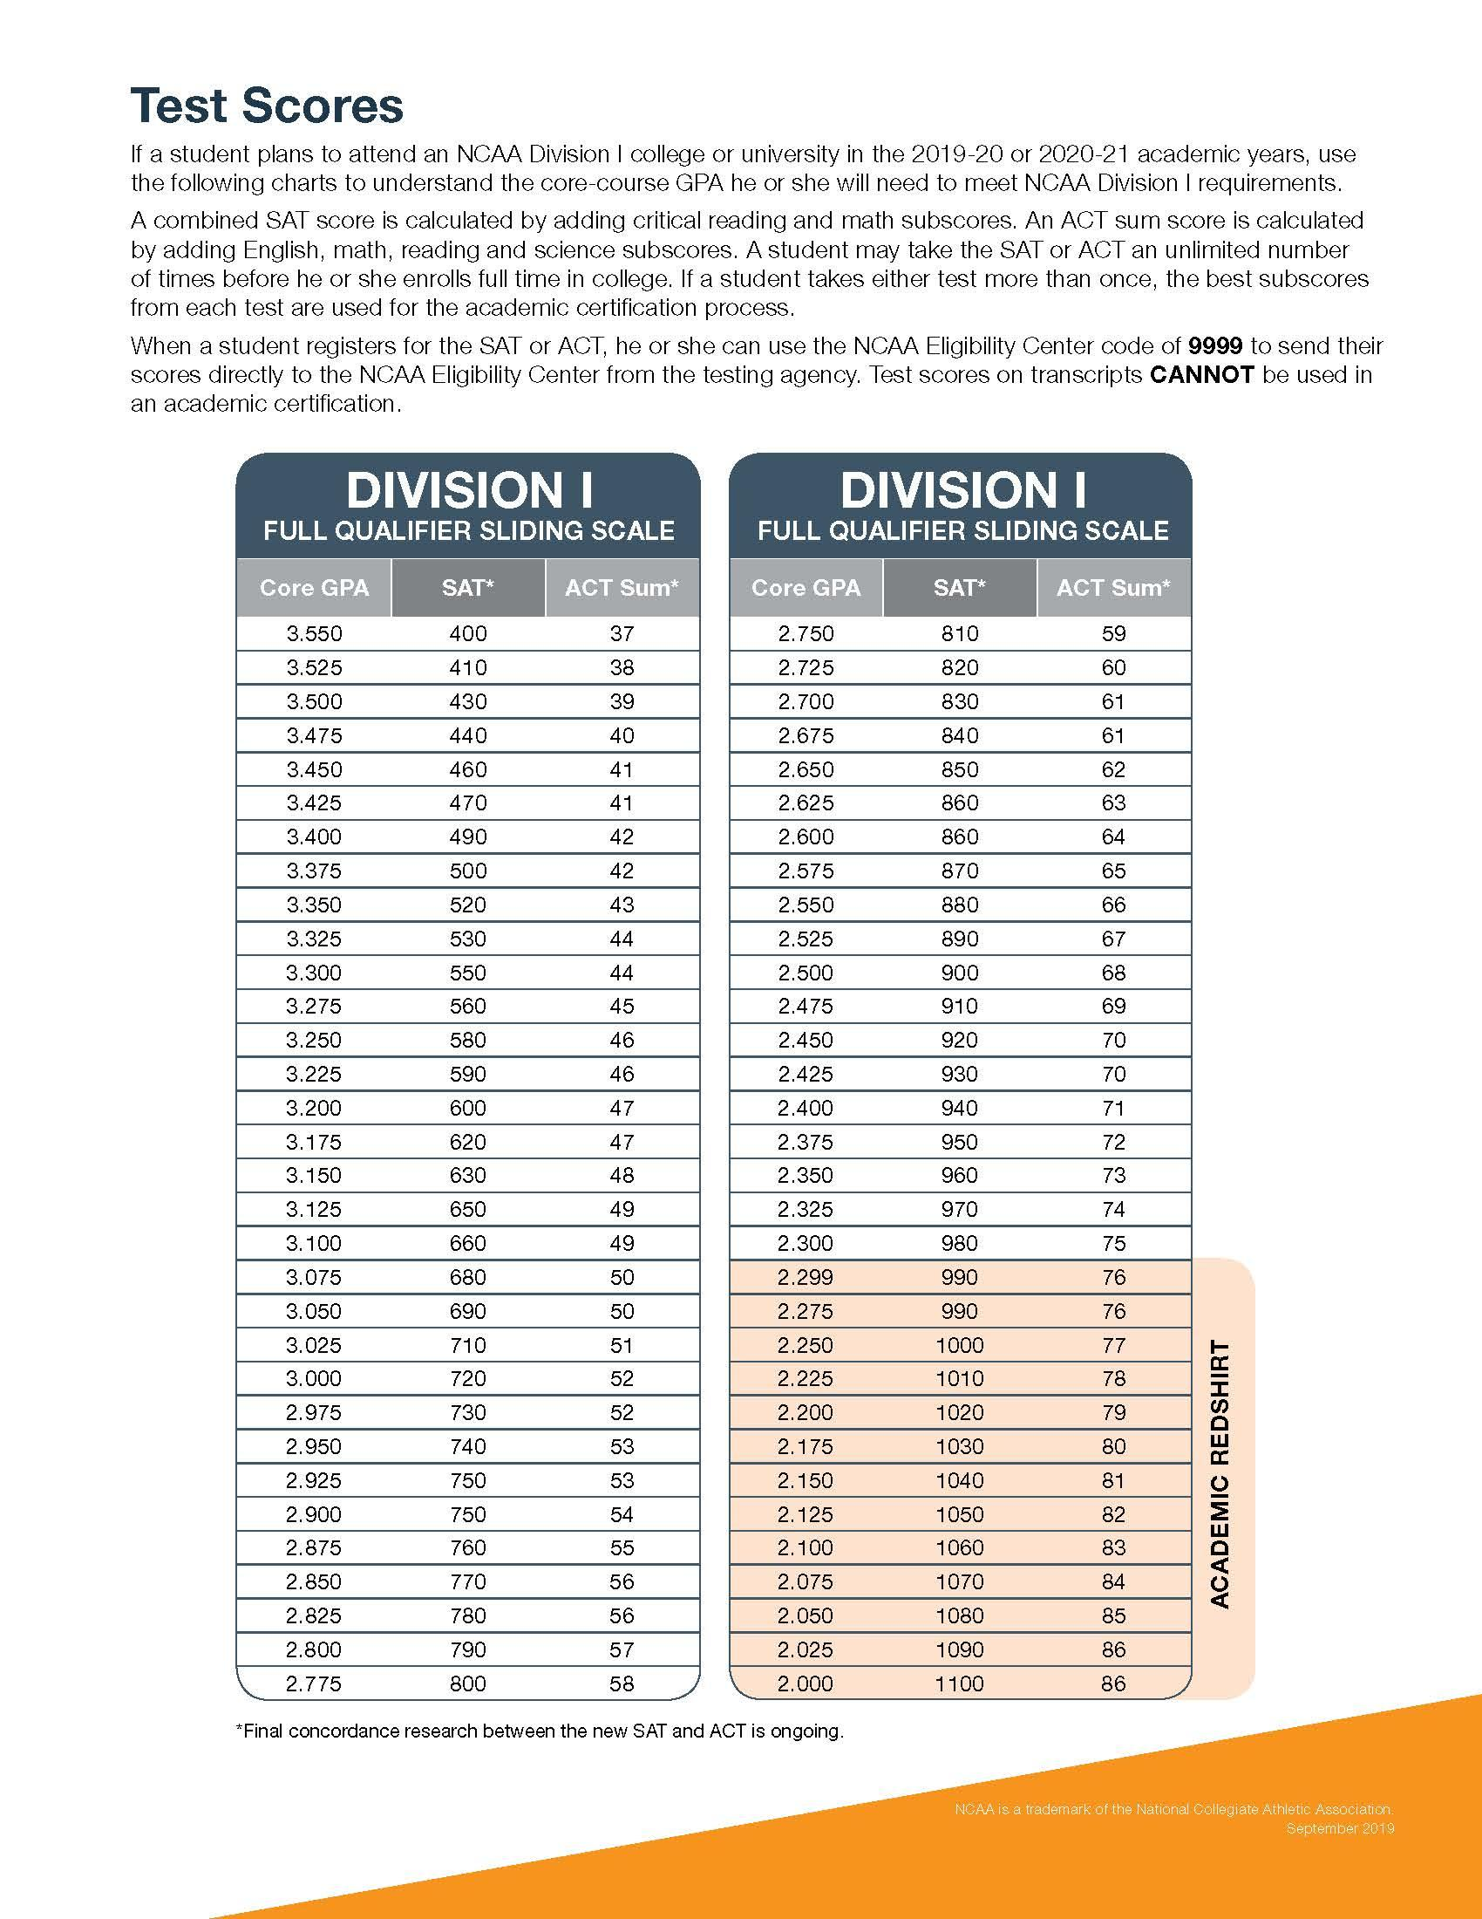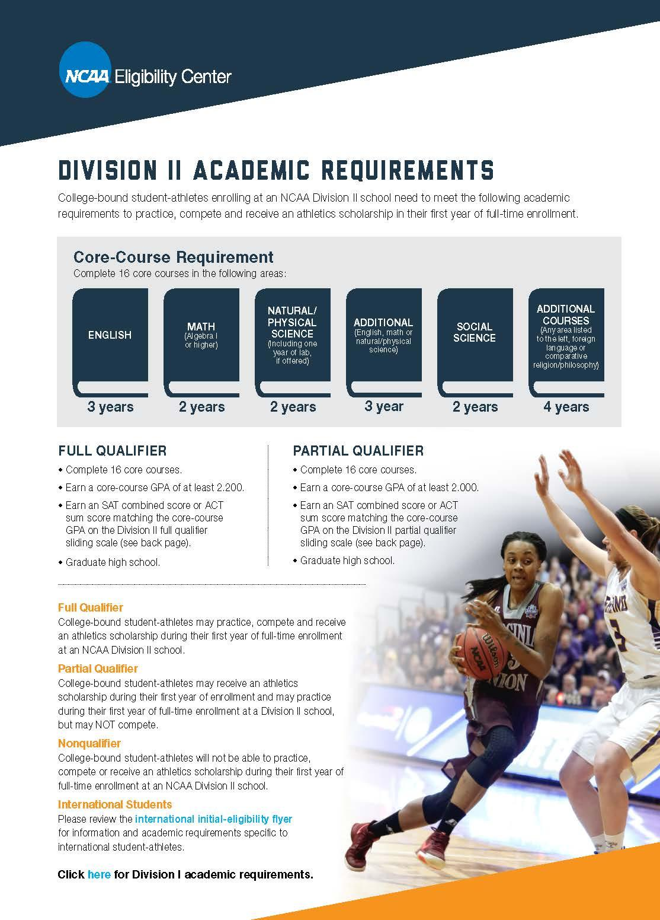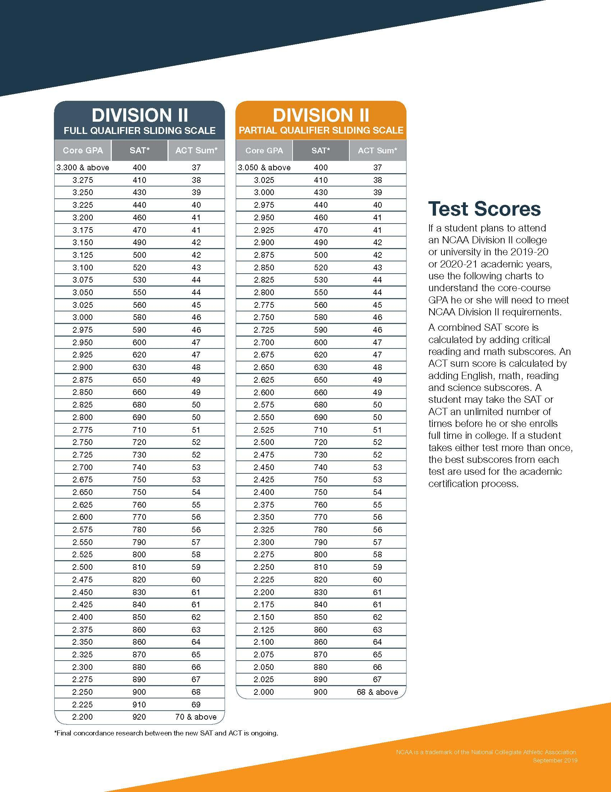

**(This form is required for students involved in MSHSAA Sports and Activities)**

**CITIZENSHIP STANDARDS FOR ELIGIBILITY**

NAME: ________________________________________ GRADE: ________

Student activities in the Marshfield R-I School District provide a program for students to pursue social interests in addition to the more formal class activities. Student activities help develop leadership abilities, promote school spirit and loyalty, establish habits of good citizenship, and provide opportunities to learn to work as part of a group. Although student activities are important for all-around development for students, they must be of secondary importance, *regular classroom work must come first*.

The Marshfield High School Activities Handbook contains the following information.

Creditable citizenship shall be one of the criteria for participation in school activities. Credible citizenship includes such things as regular and punctual attendance and a quality of conduct which promotes the best interest of the school.

Repeated referrals of a student to the office for misbehaving may be sufficient reason to declare a student ineligible. A single breach of good conduct, either in or out of school may also be sufficient cause for declaring a student ineligible to participate in a school activity.

The Marshfield R-I School District Activity Program has traditionally been represented by excellent students who are outstanding citizens. Only a few students make errors in judgment which makes necessary a review of the citizenship policy for the Marshfield R-I School District and are applicable to any who represents their school.

Participation in student activities is a privilege and not a right, therefore, the School Board believes that students must adhere to standards which will bring credit to the individual student, the activity and the community. The School Board insists that student behavior be in compliance with Board policy, with the Student Handbook Regulations and with public law. Behavior not in compliance may result in suspension or expulsion from all extracurricular activities. While it is not possible to cite every example of behavior that violates policies, regulations or public laws, there are certain behaviors that are more frequently a problem for school systems than others and will be addressed herein. Specifically, twenty-eight (28) calendar day suspension from the activities program will be assessed for a violation of the alcohol/drug policy. A second violation will result in a three hundred and sixty-five (365) calendar day suspension from activities. A minimum seven (7) calendar day suspension from the activities program will be assessed for violation of the tobacco policy. A second violation will result in a twenty-eight (28) calendar day suspension from activities. Students may practice after the first violation but not participate in contests or games or travel with teams. Violations of public law must be brought to the attention of the school administrators. A student charged with crimes will be suspended until all charges have been dropped or the student has satisfied all requirements of the court with exception of probation. The School Board also believes that consistent administration of the policies is important from school to school and from activity to activity, and that appropriate *due process* procedures must be followed before any student is suspended from participation.

In addition to these standards students must abide by the rules and regulations of the Missouri State High School Activities Association (MSHSAA). The following rules are included in the rules to the MSHSAA handbook and are listed here to help students and parents understand state requirements and to help avoid a misunderstanding which could lead to violations of eligibility standards.

1. A student who misses class on the date of a contest shall not be considered eligible to represent their school on that date without previous permission of Administration.
2. Any student who withdraws from school because of disciplinary measures shall not be eligible for any interscholastic activity for one full year from the date of withdrawal.
3. A student in grades 9-12 must be currently enrolled in courses that offer a total of 3 units of credit, and they must have earned 3 units of credit in courses in the preceding semester.
4. A beginning ninth grade student shall have been promoted from 8th grade to 9th grade for the first semester eligibility.
5. Non-school competition: Before competing in any Non-school competition, check with your coach or Athletic Director.
6. The school shall require of each student before the student is allowed to practice

or participate, a physician’s certificate stating that he or she is physically able to participate in athletic contests.

Please sign and return to your coach or activity sponsor. No student will be allowed to participate in any interscholastic activity before the public until this form is signed and on file in the office.

__________________________________ _____________________________

(STUDENT’S SIGNATURE) (PARENT’S SIGNATURE)

**ATHLETIC/ACTIVITY RANDOM DRUG TESTING POLICY**

Students electing to participate in junior high or high school activities/athletics representing Marshfield R-I Schools are subject to the guidelines of the random drug testing policy. Copies of the Marshfield R-I Board of Education Random Drug Testing Policy as well as the parent consent form are included in this handbook. Students choosing participation in the following sports/activities (as well as any other manner in which students physically represent Marshfield Schools) are subject to random drug testing:

Art Club (JH)

Band (including HS Color Guard) Performances/Competitions (JH & HS)

Baseball (HS)

Basketball (JH & HS)

Center Stage (HS)

Cheerleading (JH & HS)

Cross Country/Track (JH & HS)

Drama Productions & Competitions (JH & HS)

FFA (HS)

Family, Career & Consumer Leaders of America (HS)

Football (JH & HS)

Foreign Language Club (HS)

Future Business Leaders of America (HS)

Gaming Club (HS)

Golf (HS)

Harry Potter Club (HS)

Jaywalkers (HS)

Marshfield Equestrian Students’ Assoc. (HS)

National Art Honor Society (HS)

National Honor Society (HS)

Photographic Society (HS)

Quill and Scroll (HS)

Soccer (HS)

Softball (JH & HS)

Speech and Debate Performances/Competitions (JH & HS)

Student Council/Cabinet (JH & HS)

Students Opposing Destructive Actions Club (HS)

Swimming (HS)

Technology Student Association (HS)

Vocal Music Performances/Competitions (JH & HS)

Volleyball (JH & HS)

Wrestling (JH & HS)

Occasionally other clubs are formed during the school year. The Student Government Association and administration of the respective school must approve these clubs. Upon approval participants must be compliant with the random drug testing policy.

STUDENTS Board of Education Policy S-196-P

ACTIVITIES AND ATHLETICS

RANDOM DRUG TESTING

**Statement of Intent**

Alcohol and drug abuse are serious problems today in America, and schools including Marshfield R-I Schools are not immune. The administration of Marshfield R-I Schools have noted and documented both formally and informally an increase in the use of drugs and alcohol by students, including those students participating in extracurricular and co-curricular activities. The administration and School Board support a zero tolerance policy and believe that all students in the Marshfield R-I Schools have a right to participate in extracurricular and co-curricular activities in a safe and drug free environment.

The goal is not to levy discipline, but rather to aid in the discovery and prevention of possible drug-related problems. A goal of this program is to open the lines of communication between the parents, students, and the school in dealing with drug and alcohol abuse.

In an effort to protect the health and safety of its students from illegal drug use and abuse or injuries resulting from the use of drugs, Marshfield R-I Schools adopts the following policy.

**Definitions**

**Alcohol:**Defined as ethyl alcohol or any beverage containing ethyl alcohol.

**And/or:**These words, when used together, shall be construed conjunctively rather than disjunctively, so as to bring within this policy what might otherwise be viewed as outside of this policy.

**Illegal Drugs:**The synthetic or generic equivalent or derivative drugs which are illegal under federal, state, or local laws, including but not limited to marijuana, alcohol, heroin, hashish, cocaine, hallucinogens, depressants, and stimulants not prescribed for the user. Illegal drugs include steroids and steroid derivatives or related substances, which are not prescribed by a physician or are prescribed by a physician for uses not authorized by the manufacturer of the drug. This term shall include but shall not be limited to all drugs listed in the Narcotic Drug Act, section 195.101, RSMo, and Section 202 of the Controlled Substances Act, 21 U.S.C. 812.

**Random Testing:**Students covered by this policy will be subject to random selection for testing. In implementing the procedure, each student participating in extracurricular activities will be assigned a number. On each testing day, a predetermined number of said students will be selected using a table of random numbers (done by an outside firm). If a student selected in this manner is absent, a student from the list of alternates will be used.

**Co-curricular Activities**: Activities that students participate in outside of the classroom as a result of being enrolled in a school-offered class.

**Extracurricular Activities:** Activities that take place outside the regular course of study in school and are sponsored by the school.

**Pending Positive Test**: Any test that once initially tested shows a positive result. A lab has not yet verified this test.

**Positive Drug Test**: A drug test administered under this policy, a toxicological test result which is considered to demonstrate the presence of an illegal drug or the metabolites thereof using the standards customarily established by the testing laboratory administering the drug use test. This term may alternatively be referenced as a "positive," a "positive test," or a "positive result."

**Procedure**

Each student wishing to participate will be required to complete a consent form and return it to the high school / junior high office within the first ten days of school. Any newly enrolling student and the parent / guardian will have ten days from the date of enrollment to sign and return a consent form. Any student not completing the consent form and returning it within the prescribed time will be ineligible to participate in extracurricular and/or co-curricular activities for the entire school year.

A student in grade seven or eight and any newly enrolling student in grades 9-12 may appeal to join the drug testing pool in order to participate in an activity at a later date during the school year. A ninth grade student may appeal to join the drug testing pool only during the first semester. The appeal must be submitted in writing and will then be reviewed by a committee of school personnel. A student electing to follow the appeal process is not guaranteed participation in activities.

Students will be required to provide urine or saliva samples as follows:

1. On a random selection basis during the regular school year, ten high school students and five junior high school students will be chosen approximately every two weeks from a list of all students participating in extracurricular and/ or co-curricular activities; and
2. One voluntary staff member will be chosen at random to be tested.

Any drug test required by the Marshfield R-I School District under the terms of the policy will be administered by a third party administrator using an immunoassay test. A pending positive is then confirmation tested at a federally approved toxicology laboratory using scientifically recognized toxicological methods. The certified laboratory shall be required to have written specifications to assure chain of custody of the specimens, proper laboratory control and scientific testing.

All aspects of the drug-use testing program, including the taking of specimens, will be conducted so as to safeguard the personal and privacy rights of students and staff to the maximum degree possible. The test specimen shall be obtained in a manner designed to minimize the intrusiveness of the procedure. In particular, the student will be allowed to give the urine specimen in a private restroom behind a closed door. The monitor shall wait outside the door until the specimen has been produced. The student will hand the specimen to the monitor who will thereafter verify the normal warmth and appearance of the specimen. The monitor will then test the specimen. If at any time during the testing the monitor has reason to believe or suspect that a student is tampering with the specimen, the monitor may stop the procedure and inform the principal who will then determine if a new sample should be obtained.

If, during the drug testing procedure, a student delays urination beyond a reasonable period of time a saliva test may be administered. Ifthe monitor witnesses anything indicating an attempt to tamper with the specimen or otherwise interfere with monitor's ability to detect illegal drugs, or if there is a reasonable suspicion of use of a test altering substance, the district may send the sample to the drug lab for more specific and accurate tests regardless of whether the first test is negative. If the initial test is positive, the initial test result will then be subject to confirmation by a second and different test of the same specimen. In order to keep the results of the initial testing confidential, the district may choose a certain number of samples for a confirmation test. The second test will use gas chromatography/mass spectrometry technique. A specimen shall not be reported positive unless the second test utilizing the gas chromatography/mass spectrometry procedure is positive for the presence of an illegal drug of the metabolites thereof.

If the gas chromatography/mass spectrometry test for any student has a positive result, the principal will contact the parents or guardians and solicit any information on medication, which would create a positive test. A medical review officer will confirm the positive result and contact the principal with the results. The principal will then notify the parents/guardian.

**Appeal Procedure**

Within two (2) working days of receipt of the positive drug test, the principal will contact the activities director, coach/sponsor, and or other individual responsible for supervising the extracurricular or co-curricular activity. The principal will then within two (2) working days contact the student, the parent or custodial guardian to schedule a conference. The conference shall be held within ten (10) working days of initial contact with the student or the custodial guardian. If the student, parent or custodial guardian refuses to participate or respond to a request for a conference, the student will be deemed to have waived any right to further appeal the positive drug test.

If a conference is held, the principal will solicit any explanation of the positive drug test. If the student asserts that the positive drug test is caused by other than the consumption of an illegal drug, then the student, parent or custodial guardian will be given ten (10) working days from the date of the conference to present evidence to the principal. If the student fails to or refuses to present any evidence within the 10-day period, the student will be deemed to have waived any right to further appeal the positive drug test. The Marshfield R-I School District will rely on the opinion of the laboratory which performed the confirmation test in determining whether the positive test result is other than the consumption of an illegal drug. The principal will make a decision within two (2) working days of presentation of the student's evidence.

This decision may be appealed in writing to the Marshfield R-I School District's Superintendent within two (2) working days. Failure to appeal to the superintendent waives any further right to appeal the positive drug test. The superintendent will make a decision within two (2) working days.

The decision of the superintendent may be appealed to the Marshfield R-I Schools Board of Education within five (5) working days. Failure to appeal to the Board of Education waives any further right to appeal. The procedures set forth in Board of Education policy 2671 will be generally followed in case of appeal. However, the Board of Education reserves the right to modify such procedures as it determines to be appropriate under the circumstances.

Initiating appeal procedures does not suspend imposition of the restrictions listed below while the appeal process is ongoing.

If a student tests negative in the initial screening, the student and the parent or custodial guardian will be contacted by personnel of the Marshfield R-I School District within five (5) working days of receipt of the testing results.

**Retest After Service of Suspension**

At the conclusion of the 28-day activity suspension the student will be allowed to rejoin the activity/sport. A student who has tested positive and has served the required suspension period will be required to undergo one or more additional drug-use tests during the following 365 days, as determined at the discretion of the Marshfield R-I School District. He/she will again be drug-tested on the first random testing date following the activity suspension. In the case of retesting a student suspended for marijuana, a lower level of the substance might continue to be evident for up to 90 days because of the extended length of time the substance stays in the body. In this situation the student would continue activity participation. If the marijuana level stays the same or increases on the additional tests it will be treated as a second positive test. It will also be considered a second positive if any level is detected after 90 days.

**Confidentiality**

Test results shall be kept in confidential files separate from a student's permanent educational records and those files will be destroyed upon the student's graduation from school. Test results shall be released to school personnel only on a "need to know" basis. For the purpose of the random drug testing process a number assigned by the principal will identify all students. The students' names will not be disclosed to the drug testing company unless the sample collected requires further testing because of being identified as a pending positive.

**Violations**

Any student who tests positive in a drug-use test under this procedure shall be subject to the following restrictions:

1. **First Offense**

The student shall be suspended from participation or attendance in all extracurricular and/or co-curricular activities for twenty-eight (28) calendar days from the date of the positive drug test. During this time the parent/guardian may obtain -- at the parent/guardian's own expense -- a substance abuse evaluation and education/ counseling for the student. Students who are enrolled in a class that involves co-curricular activities will remain in the class during the twenty-eight (28) days and may participate in classroom activities, but may not participate in any activities outside the regularly scheduled class time.

If, because of the suspension, the student is unable to participate in the activity which constitutes a portion of the student's grade, the student will be given the opportunity to complete alternative assignments so that the student can earn the grade as he/ she would have had they been allowed to participate in the activity.

1. **Second Offense**

The student shall be suspended from participation or attendance in all extracurricular and/or co-curricular activities including all meetings, practices, performances, and competitions for 365 days from the date of the positive drug test of the second offense as stated in this procedure.

If, because of the suspension, the student is unable to participate in an activity which constitutes a portion of the student's grade the student will be given the opportunity to complete alternative assignments so that the student can earn the same grade as he/she would have had they been allowed to participate in the activity.

1. **Third Offense**

The student shall be suspended from participation or attendance in all extracurricular and/or co-curricular activities including all meetings, practices, performances and competitions for the length of the students enrollment at Marshfield R-I School District from the date of the positive drug test of the third offense as stated in this procedure.

If because of the suspension, the student is unable to participate in an activity which constitutes a portion of the student's grade, the student will be given the opportunity to complete alternative assignments so that the student can earn the same grade as he/she would have had they been allowed by participating in the activity.

**Refusal to submit to Drug Use test**

If a member of the random drug testing pool refuses to submit to a drug use test authorized under this policy, the refusal to be tested will be treated as a positive drug test and such student will be ineligible to participate or attend any extracurricular and/or co-curricular activities including all meetings, practices, performances, and competitions for the length of the suspension, at which time they would have the opportunity to submit to the authorized test. Additional refusal would eliminate that student from extracurricular and/or co-curricular events for one year. Continual refusal will be treated as positive drug tests under this policy, which will result in loss of eligibility for the remainder of their high school career.

Requesting removal from the pool will automatically cause the student to be suspended from participation or attendance in all extracurricular and/or co-curricular activities including all meetings, practices, performances, and competitions for 365 days.

**Drug Counseling and Assistance**  
  
The main goal of this drug testing policy is to educate students regarding the serious problems of drug and alcohol abuse. As such, drug counseling and assistance programs may be sought by the parents of any student who has a positive drug test under this policy. If requested by the parents/guardian, assistance in obtaining help for the student will be provided by the school counselors. Any costs for assistance otherwise or enrollment into any drug counseling sessions will be exclusively the responsibility of the student or parent guardian.

**Board Approved Date:** July 2023

MARSHFIELD R-I SCHOOLS

Random Drug Testing Program Participation and Consent Form for Eligibility in the Athletics/Activity Program (school year 2023-2024)

Student's Name______________________________ Grade_______

As a school's participant in athletics and/or activities I understand that participation is completely voluntary. I understand that my signature below authorizes the Marshfield R-I School District to obtain a urine sample from the student whose name appears above if his/her name is selected as part of the random selection procedures of the Drug Testing Program. I also understand that currently available instant screen tests are not 100% reliable and that an instant screen test that shows positive will always be followed with a more sophisticated laboratory test for confirmation as described in the Random Drug Testing Policy. I also understand that if a “positive” test results, the student and parents or guardians may need to disclose to the laboratory or its medical review officer any over-the-counter or prescription medications the student is or has taken. I understand that if a violation of the drug-testing policy occurs, the parent/legal guardian of the student, building administration, and the respective coach/activity sponsor will be the only individuals made aware of this information. I further understand and agree that the Marshfield R-I School District may respond to a positive drug test result in accordance with the provisions of the Random Drug Testing Policy.

This completed form must be returned to the Junior High/High School office within 10 days from entry into school.

By checking YES and signing this form, the parent/legal guardian and student understand and agree as follows:

The student and parent have read and understand the guidelines for participation in the Marshfield R-I School athletic/activities program as set forth in the athletic/activities handbook.

The student is compliant with all MSHSAA and Marshfield R-I school bylaws.

If participating in a sport, the student must successfully pass a physical examination by a physician, and a copy of such examination must be on file in the athletic director’s office prior to participation in practice of the sport.

_____Yes. I agree to participate in the Marshfield R-I random drug testing pool. I, along with my parent/legal guardian, have read and understand the guidelines set forth by the Marshfield R-I Random Drug Testing Policy. (Please sign this consent form and return it within the first ten days of school (by August 31, 2023).

_____No. I do not agree to have my child's name placed in the Marshfield R-I random drug testing pool. I further understand that by making this decision I relinquish my child's privileges to represent Marshfield R-I Schools in extra and co-curricular activities.

Student's Signature _______________________________ Date__________

Parent's Signature ________________________________ Date_______

**FOR OFFICE USE**

Date Received in the Principal’s Office __________________

Received By:_______________________________________